Teaching Plan for Year 2021-2022, 2nd Grade, 1st Semester
Text Book: Everybody Up Book1 & Story Books
Date | Units | Vocabulary | Sentences Structures
8/29-9/04  9/05-9/11 | Unit1  L3&4 |  | L3: Story: I’m Great!  How are you?/ I’m fine. /  Thank you.  (Be friendly)
 |  | L4:Shapes:  circle, square, triangle, rectangle | Is it a circle?  Yes, it is. / No, it isn’t.
9/12-9/18  9/19-9/25 | Story Book  Circus Shapes  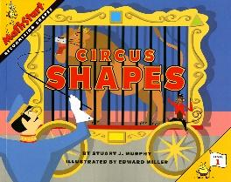 | Author: Stuart J. Murphy  Illustrator: Edward Miller  https://www.youtube.com/watch?v=ZZOsYowsg0E | 1 Elephants make a circle.  2 White horses make a triangle.  3 Some monkeys make a square.  4 The bears form a rectangle.
 |  | Circus, ringmaster, circle, triangle, square, rectangle, corner, side
9/26-10/2  10/3-10/9 | Unit2  L3&4 |  | L3: Story: The Blue Paint.  Let’s share. / OK.  (Be nice)
 |  | L4: Colors  green, purple, orange, pink, gray, brown, black | Blue and yellow make green.
10/10-10/16  10/17-10/23 | Story Book  A Color of His Own  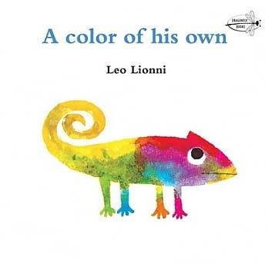 | Author: Leo Lionni  Illustrator: Leo Lionni  https://www.youtube.com/watch?v=Y8rab-HcTN0 | 1 Parrots are green.  2 Goldfish are red.  3 Elephants are gray.  4 Pigs are pink.  5 All animals have a color of their own.
 |  | green, red, gray, pink, yellow, purple,
10/24-  10/30 | Review
11/1  -11/6 | FTs' Midterm Oral Exam/ Wenhua Exam
11/7-11/13  11/14-11/20 | U3  L3&4 |  | L3: Story: My Turn!  It’s your turn. /Thank you.  (Be fair)
 |  | L4: Toys  game, marble, puzzle, card | I have one game.  I have two games.
11/21-11/27  11/28-12/4 | Story Book  I Love My New Toy  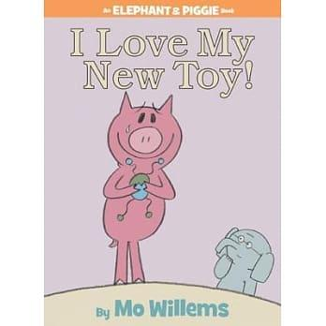 | Author: Mo, Willems  Illustrator: Mo, Willems  https://www.youtube.com/watch?v=T-gxMtfBhSU | 1 I love my new toy.  2 Here, try it.  3 You broke my toy.  4 I’m sorry.  5 Friends are more fun than toys.
 |  | new, mad, sad, sorry, broken, fun
12/5-12/11  12/12-12/18 | U4  L3&4 |  | L3: Story: Cookies  Here you are. /Thank you. / You’re welcome.  ( Be kind)
 |  | L4: Food  pizza, rice, bread, cake | What’s this?  This is pizza. I like pizza.
12/19-12/25  12/26-01/01 | Story Book  Me and My Family Tree  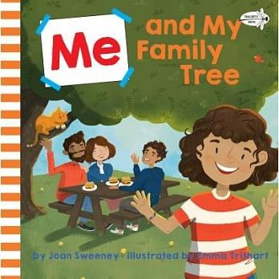 | Author: Joan Sweeney  Illustrator: Emma Trithart  https://www.youtube.com/watch?v=O-sls-CzzlQ | 1They’re all part of my family tree.  2 Everyone in the world has a family tree.
 |  | me, brother, sister, parents, mommy, daddy, grandpa, grandma, uncle, aunt, cousin, family tree,
1/2  1/8 | Review
1/9-  1/15 | FTs' Final Oral Exam/ Wenhua Exam
01/16-  01/20 | Chinese New Year’s Activities/English Activities

