Teaching Plan for Year 2021-202, 2nd Grade, 2nd Semester
Text Book: Everybody Up Book1 & Story Books
Date | Units | Vocabulary | Sentences Structures
2/6-2/12  2/13-2/19 | Unit5  L3&4 |  | L3: Story: My Kite  Please help me. Sure.  (Be helpful)
 |  | L4:Animals  turtle, frog, spider, ant | Can you see a turtle?  Can you see an ant?  Yes, I can. / No, I can’t.
2/20-2/26  2/27-3/5 | Story Book  Sleeping Animals  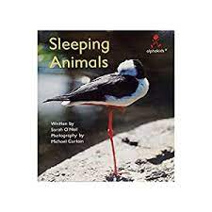 | Author: Sarah O'Neil  Photography: Michael Curtain  ________________________  this, is, a, it, can, in, down, its, on, up, all, they | This is a __________ .  It can sleep __________ .
3/6-3/12  3/13-3/19 | Unit6  L3&4 |  | L3: Story: Where’s Danny?  I’m sorry. That’s OK.  (Be safe)
 |  | L4: Abilities  Run, hop, swim, walk | Can zebras run?  Yes, they can. / No, they can’t.
3/20-3/26  3/27-4/2 | Story Book  Elephants Cannot Dance!  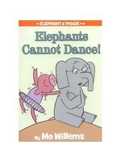 | Author: Mo, Willems  Illustrator: Mo, Willems  https://www.youtube.com/watch?v=HupcfibCjCY  ___________________  teaching, friends, learn, dance, try, jump, spin, stop, forward, backward. | - Let’s dance.  - Elephants cannot dance.  - I can teach you.  - You are kidding me.  - I can try to dance.  - Jump with me when I count to three.  - We will try again.  - We are ready to learn some moves.  - My friend is sad.
4/3-4/9 | Review
4/10-4/16 | FTs' Midterm Oral Exam/ Wenhua Exam
4/17-4/23  4/24-4/30 | U7  L3&4 |  | L3: I Can’t See.  Excuse me. Sure. Thank you.  (Be polite)
 |  | L4: Healthy Habits  wash my face, wash my hands, brush my hair, brush my teeth | I can wash my face.
5/1-5/7  5/8-5/14 | Story Book  Germs are not for sharing  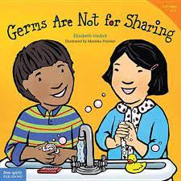 | Author: Elizabeth Verdick  Illustrator: Maricka Heinlen  ______________________  need, tissue, blow, wipe, toss, cough, germ, share, sick, flush, wash, scrub, rinse, sneeze, kisses, blow, catch, | - Germs are not for sharing.  - What do you need to do?  - Good job.  - Cough into your sleeve.  - Germs can make you sick.  - Put it in the trash.  - Go and wash your hands.  - Before it’s time to eat.  - Send those germs down the drain.
5/15-5/21  5/22-5/28 | U8  L3&4 |  | L3: Story: Please Be Quiet  Please be quiet. OK. I’m sorry. Thanks.  (Be nice.)
 |  | L4: Transportation  bus - buses  truck - trucks  trains - trains  boat - boats | What's this/that?  It's an [adj] noun.  What are these/those?  They're [adj] [noun+s].
5/29-6/4  6/6-6/11 | Story Book  Coco Can’t Wait!  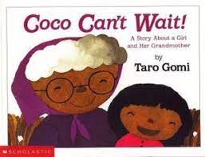 | Author: Taro Gomi  Illustrator: Taro Gomi  https://www.youtube.com/watch?v=dXaRoNVvhOg  _____________________  want, see, Dear me! Oh no!, wait, meet, middle, tree | - One day Coco wanted to see Grandma very much.  - Dear me! Coco is not here!  - I can’t wait any longer.  - Next time, Grandma, let’s meet in the middle, right under this tree.
6/12-6/18 | Review
6/19-6/25 | FTs' Final Oral Exam/ Wenhua Exam
6/26-6/30 | Feedback

