G2_Foreign Teacher’s Teaching Plan for Year 2022-2023, 1st Semester
二年級 外師課程規劃 (課堂上教學的繪本、繪本中的單字句型)
Text Book課本 : Everybody Up Book1 (每個單元的L3 + L4 )
& Story Books (與L4相關的故事繪本)

由繪本衍伸出來的單字句型(淺底色部分)，不需要記憶單字拼法，但是須會認讀單字、句型，會唸、聽到可以指認圖片、看到圖片可以說出單字句型…等。

Date | Units | Vocabulary | Sentences Structures
08/30-09/23 | Unit1  L3&4 |  | L3: Story: I’m Great!  How are you?/ I’m fine. /  Thank you.  (Be friendly)
 |  | L4:Shapes:  circle, square, triangle, rectangle | Is it a circle?  Yes, it is. / No, it isn’t.
 | Story Book  Circus Shapes  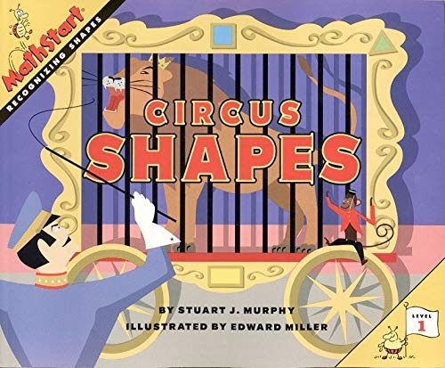 | Author: Stuart J. Murphy  Illustrator: Edward Miller  https://www.youtube.com/watch?v=ZZOsYowsg0E | 1 Elephants make a circle.  大象做了一個圓  2 White horses make a triangle.  白馬做了一個三角形  3 Some monkeys make a square.  猴子做了一個正方形  4 The bears form a rectangle.  熊做了一個長方形
 |  | circus(馬戲團), ringmaster(馬戲團演出指揮), corner(角落), side(邊), acrobat(雜技演員), whistle(哨子), wagon(四輪馬車), clown(小丑), tent(帳篷)
09/26-10/14 | Unit2  L3&4 |  | L3: Story: The Blue Paint.  Let’s share. / OK.  (Be nice)
 |  | L4: Colors  green, purple, orange, pink, gray, brown, black | Blue and yellow make green.
 | Story Book  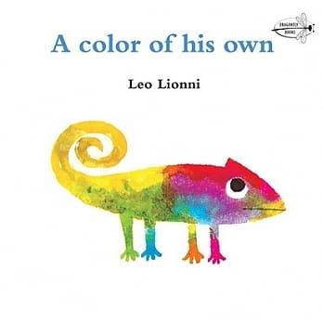  A Color of His Own | Author: Leo Lionni  Illustrator: Leo Lionni  https://www.youtube.com/watch?v=Y8rab-HcTN0 | 1 Parrots are green.  鸚鵡是綠色  2 Goldfish are red.  金魚是紅色  3 Elephants are gray.  大象是灰色  4 Pigs are pink.  豬是粉紅色  5 All animals have a color of their own.所有動物都有自己的顏色
 |  | parrot(鸚鵡), chameleon(變色龍), goldfish(金魚), elephant(大象), autumn(秋天), winter(冬天), cheerfully(開心的), striped有條紋的), branch(樹枝), blow(吹), climb(爬), turn(變成), change(改變)
10/17-10/21 | Review
10/24 –  11/ 02 | FTs' Midterm Oral Exam/ Wenhua Exam
11/03-11/25 | U3  L3&4 |  | L3: Story: My Turn!  It’s your turn. /Thank you.  (Be fair)
 |  | L4: Toys  game(遊戲), marble(彈珠), puzzle(拼圖), card(卡片) | I have one game.  I have two games.  我有__
 | Story Book  I Love My New Toy  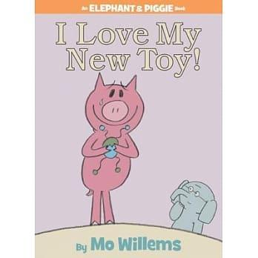 | Author: Mo, Willems  Illustrator: Mo, Willems  https://www.youtube.com/watch?v=T-gxMtfBhSU | 1 I love my new toy.  我喜歡新玩具  2 Here, try it.  在這裡,試看看  3 You broke my toy.  你弄壞我的玩具  4 I’m sorry.我很抱歉  5 Friends are more fun than toys.  朋友比玩具更有趣  6 What are you doing?  你在正在做什麼
 |  | new(新的), mad(生氣的), sad(難過), cool(很酷的), sorry(抱歉), broken(壞掉), fun(有趣), throw(丟), break(弄壞), care(在乎),try(嘗試) ,enjoy(享受)
11/28-12/16 | U4  L3&4 |  | L3: Story: Cookies  Here you are. /Thank you. / You’re welcome.  ( Be kind)
 |  | L4: Food  pizza, rice, bread, cake | What’s this?  This is pizza. I like pizza.
 | Story Book  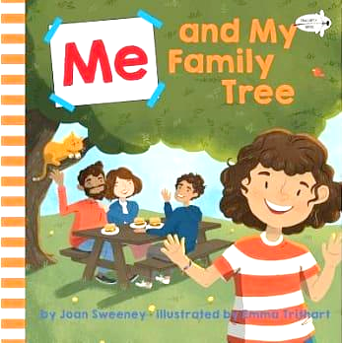  Me and My Family Tree | Author: Joan Sweeney  Illustrator: Emma Trithart  https://www.youtube.com/watch?v=O-sls-CzzlQ | 1They’re all part of my family tree.  他們都是家庭樹的一部分  2 Everyone in the world has a family tree.  世上每個人都有自己的家庭樹  3 We're both part of my family tree.  我們都是家庭樹的一部分
me(我), parents(父母), mommy(媽媽), daddy(爸爸), grandpa(爺爺),
grandma(奶奶), uncle(叔叔/舅舅/姑丈/姨丈), aunt(阿姨/姑姑/舅媽/嬸嬸), cousin(表兄弟姊妹), family tree(家庭樹), related(相關的)
12/19 – 12/23 | Review
12/26 –  01/09 | FTs' Final Oral Exam/ Wenhua Exam
01/10 –  01/20 | Chinese New Year’s Activities/English Activities

Teaching Plan for Year 2022-2023, 2nd Grade, 2nd Semester
Text Book: Everybody Up Book1 & Story Books
Date | Units | Vocabulary | Sentences Structures
2/13-  3/03 | Unit5  L3&4 |  | L3: Story: My Kite  Please help me. Sure.  (Be helpful)
 |  | L4:Animals  turtle, frog, spider, ant | Can you see a turtle?  Can you see an ant?  Yes, I can. / No, I can’t.
 | Story Book  Sleeping Animals  (班書31)  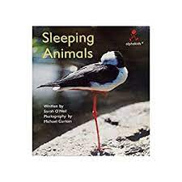 | Author: Sarah O'Neil  Photography: Michael Curtain  ________________________  bird, lizard, snake, shark, fish, giraffe, sea horse, [tortoise/ turtle], kangaroo, parrot,  [hippopotamus/hippo], sleep - sleeping, hang - hanging,  curled up, swims, | - This is a __________ .  - It can sleep __________ .  - All animals sleep.  - They sleep in different places.  - How do you think these animals sleep?
3/06-3/24 | Unit6  L3&4 |  | L3: Story: Where’s Danny?  I’m sorry. That’s OK.  (Be safe)
 |  | L4: Abilities  Run, hop, swim, walk | Can zebras run?  Yes, they can. / No, they can’t.
 | Story Book  Elephants Cannot Dance!(PPT)  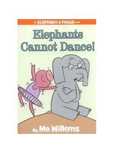 | Author: Mo, Willems  Illustrator: Mo, Willems  https://www.youtube.com/watch?v=HupcfibCjCY  _____________  teach - teaching, learn, dance, can - cannot, jump,  kidding, move, lift, spin, stop, try, | - Elephants cannot dance.  - I can teach you.  - I can try to dance.  - Jump with me when I count to three.  - We will try again.  - We are ready to learn some moves.  - My friend is sad.
3/27-3/31 | Review
4/3 – 4/14 | FTs' Midterm Oral Exam/ Wenhua Exam
4/17-5/05 | U7  L3&4 |  | L3: I Can’t See.  Excuse me. Sure. Thank you.  (Be polite)
 |  | L4: Healthy Habits  wash my face, wash my hands, brush my hair, brush my teeth | I can wash my face.
 | Story Book  Germs are not for sharing  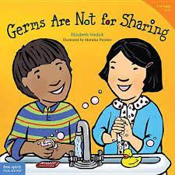 | Author: Elizabeth Verdick  Illustrator: Maricka Heinlen  https://www.youtube.com/watch?v=4swRSIpPZnY  ______________________  need, tissue, blow, wipe, toss, cough, germ, share, sick, flush, wash, scrub, rinse, sneeze, | - Germs are not for sharing.  - What do you need to do?  - Cough into your sleeve.  - Germs can make you sick.  - Put it in the trash.  - Go and wash your hands.  - Before it’s time to eat.
5/8-5/26 | U8  L3&4 |  | L3: Story: Please Be Quiet  Please be quiet. OK. I’m sorry. Thanks.  (Be nice.)
 |  | L4: Transportation  bus - buses  truck - trucks  trains - trains  boat - boats | What's this/that?  It's an [adj] noun.  What are these/those?  They're [adj] [noun+s].
 | Story Book  Coco Can’t Wait!  (教師用書-英文7)  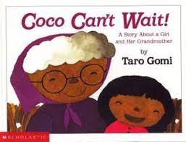 | Author: Taro Gomi  Illustrator: Taro Gomi  https://www.youtube.com/watch?v=1DjjkPjj3Xs  house, roof, want, see, Dear me! Oh no!, wait, minute, meet, middle, tree | - One day Coco wanted to see Grandma very much.  - Dear me! Coco is not here!  - I can’t wait any longer.  - Oh, how I want to see Grandma.  - Next time, Grandma, let’s meet in the middle, right under this tree.
5/29-6/2 | Review
06/05 -06/16 | FTs' Final Oral Exam/ Wenhua Exam
6/19-6/30 | Feedback

